**Netbeans right click menu help**

1. Generating getters/setters for member variables
   1. Highlight the member variables
   2. Right click
   3. Select Refactor
   4. Select Encapsulate Fields

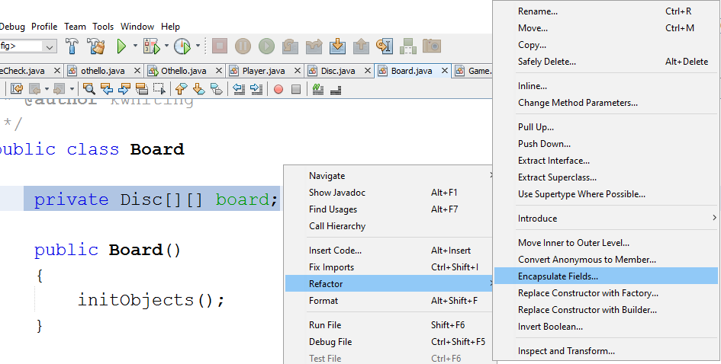

* 1. The getter/setter will automatically be selected.
  2. Click Refactor

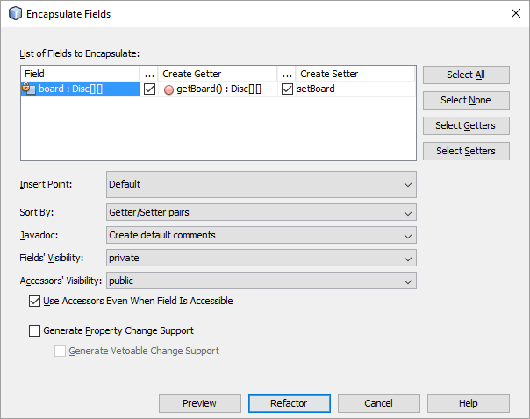

* 1. Code is automatically generated for you!

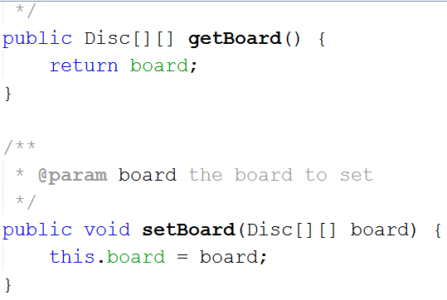

1. Import statements in Java are like #include<> statements in C, links in predefined libraries. To have the editor help you here is an example
   1. Getting an error on class Color

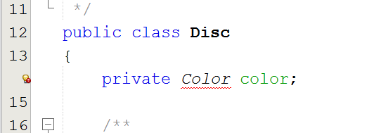

* 1. Right click in the file, select Fix Imports

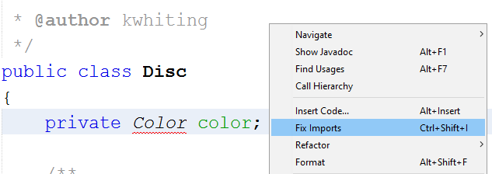

* 1. Import statements are automatically inserted and errors go away!

